Customer Registration Mobile App

Scenarios:

1. Current swimmer account (currently only take one class)-> receive email for registration (click registration url in email)->direct to log-in page-> Registration page (note: membership button is disenabled for the first stage)-> Book same time slot page (the first week registration) or -> Choose the 1st preference page (after the first week of registration) -> choose the 2nd preference page > choose the 3rd preference page

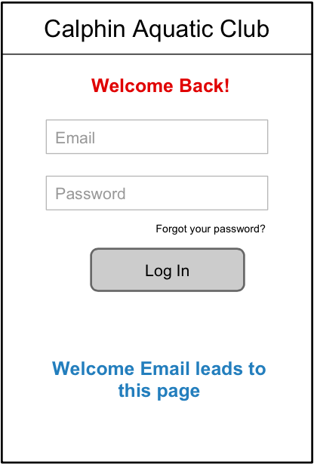 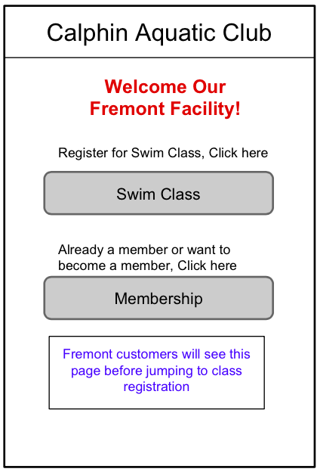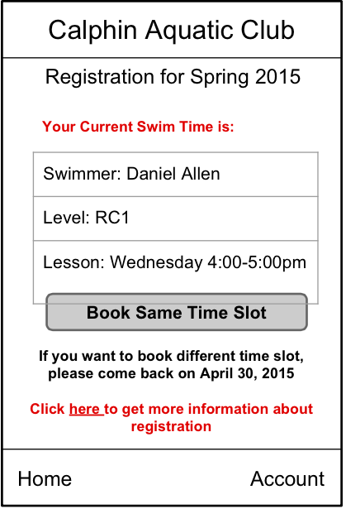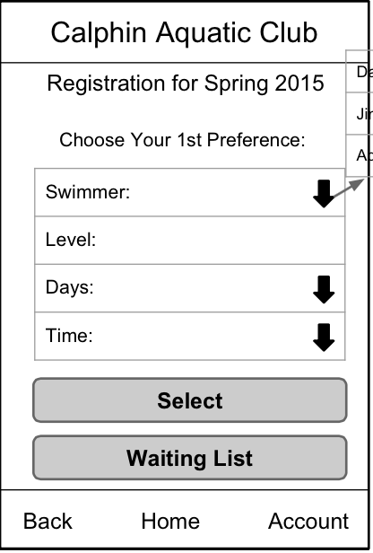

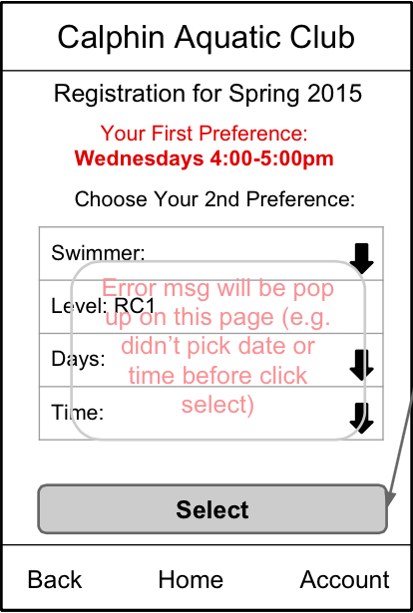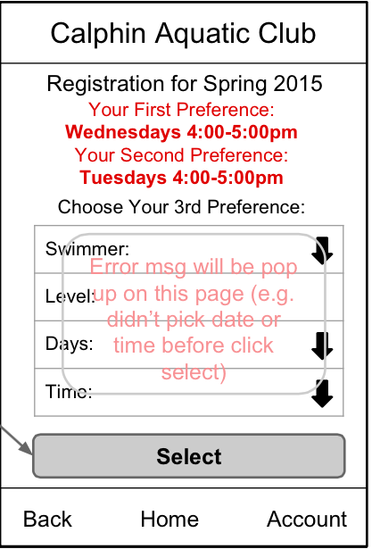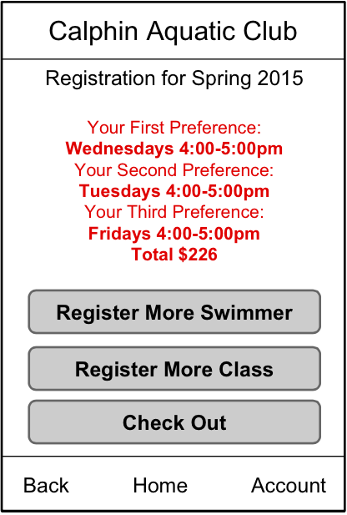

1. Current swimmer account with more than one class-> receive email for registration (click registration url in email)->direct to log-in page-> Registration page (note: membership button is disenabled for the first stage)-> Book same time slot page (the first week registration), under this scenario, this page below should show different class time. The rest is the same as scenario 1. (note: very few swimmers fall into this scenario, but they do exist)



1. Existing account with returning swimmers receive email for registration (click registration url in email)->direct to log-in page-> Registration page (note: membership button is disenabled for the first stage)-> Choose the 1st preference page (after the first week of registration) -> choose the 2nd preference page > choose the 3rd preference page



1. New customer -> direct to log-in page with account sign up-> manage my account -> add swimmer -> Registration page -> Choose the 1st preference page (after the first week of registration) -> choose the 2nd preference page > choose the 3rd preference page

